How to guide for Project Management in Salesforce.

# Definitions

**Requirement**

A requirement can be a new feature in Salesforce to improve its processes to meet the business requirements. A requirement can also be an issue that needs to be solved quickly [Type].

**User Story**

User stories are short, simple descriptions of a feature told from the perspective of the person who desires the new capability, usually a user or customer of the system. They typically follow a simple template:

As a < type of user >, I want < describe the goal > so that < describe the reason >.

**EPIC**

A large body of work that is broken down in multiple requirements.

An EPIC consists of multiple requirement (User stories)

**Project**

Large project composed of several EPICs.

**Sprint**

A short, time-boxed period where the team works to complete a set of requirements and/or EPIC’s.

# App Pages

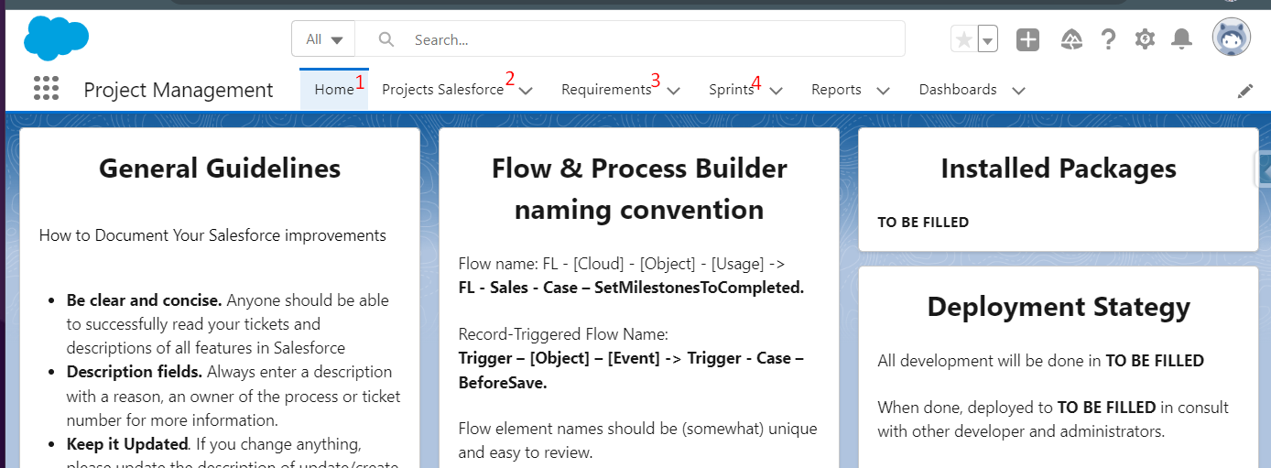

1. **Home**

The home page can be used to display an overview of the way of working in your team. By default, a template is displayed with general guidelines and how to work with Reports and dashboards for example

1. **Projects**

The tab to navigate to the project object.

1. **Requirements**

The tab to navigate to the requirement object. Requirements contain Epic and User stories.

1. **Sprint**

The tab to navigate to the Sprint Object.

# How Requirements Sprints and Project work together

A project can for example correspond to the implementation of a new Salesforce Cloud. Requirements can be related to a Project with the ‘Project Name’ lookup field. Related Requirements will show up on the Project Lightning page. Reports of Projects with Requirements can also be made.

# Requirement path:

*This is a suggested path. You can update/replace statuses and define your own path.

*You can enable path in setup to show the path section on the layout of the requirement.

1. New
2. In Progress
3. On Hold
4. Ready for Test ‘The requirement is ready for testing in a UAT or Staging environment.’
5. Ready for Deployment ‘The requirement is tested and ready to be deployed with the next release’
6. Cancelled
7. Done